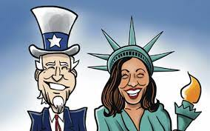

08/26/22

Event 1: Passage of a Bipartisan Gun Safety Law

* The Bipartisan Safer Communities Act passed in Senate and HR
* Not many republicans voted for it
* Requires background checks to people under 21 who want to buy a gun
* Keeps guns away from umarries dating partners convicted of abuse
* Grants money to states to help this happen
* Dems believe the law did not go far enough
* Republicans don’t support it
* Explains legislative process

Event 2: Recession?

* Economic indicated suggest we have experiences two successive quarters of declining economic activity
* Beginning stages of a recession
* Too early to call